**SHOPEE APIs REFERENCE**

# **List Exchange Rates to be Tracked**

API untuk menampilkan exchange rates 7 hari terakhir.

## **Request**

|  |  |
| --- | --- |
| URL | http://localhost/getListOfExchangeRatesWeekly/{date} |
| Method | GET |
| Header Parameter | - |

## **Response**

* Success
  + Data : menampilkan data exchange rates dalam 7 hari terakhir
  + Message : success to fetch data
  + Status : success
* Failed
  + Data : menampilkan data exchange rates dalam 7 hari terakhir
  + Message : failed to fetch data
  + Status : failed

## **Contoh Request**

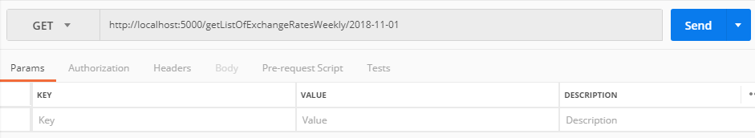

## **Contoh Response**

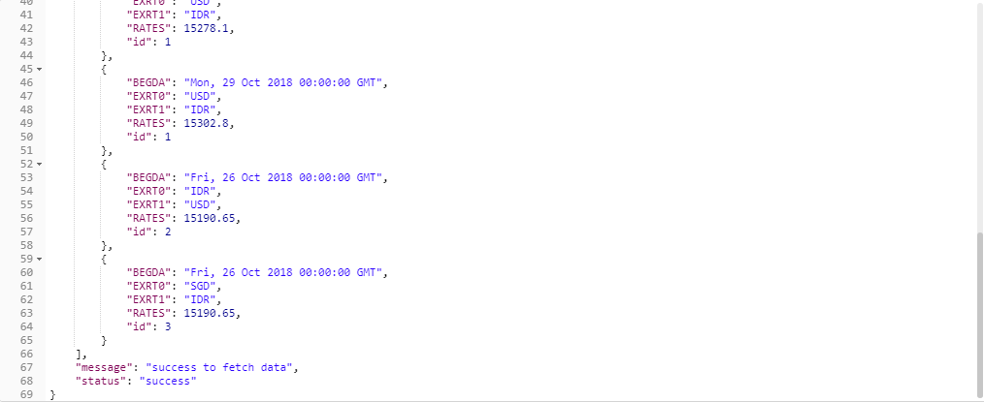

# **List Exchange Rates Trend from The Most Recent 7 data points**

API untuk menampilkan 7 data terakhir dari exchange rates.

## **Request**

|  |  |
| --- | --- |
| URL | http://localhost/getListOfExchangeRates7Latest |
| Method | GET |
| Header Parameter | - |

## **Response**

* Success
  + Data : menampilkan 7 data terakhir pada exchange rates
  + Variance : menampilkan nilai variansi dari 7 data terakhir (max. exchange rates – min. exchange rates) / “Insufficient data” apabila belum mencapai 7 records
  + Average : menampilkan nilai rata-rata dari 7 data terakhir / “Insufficient data” apabila belum mencapai 7 records
  + Message : success to fetch data
  + Status : success
* Failed
  + Data : menampilkan 7 data terakhir pada exchange rates
  + Message : failed to fetch data
  + Status : failed

## **Contoh Request**

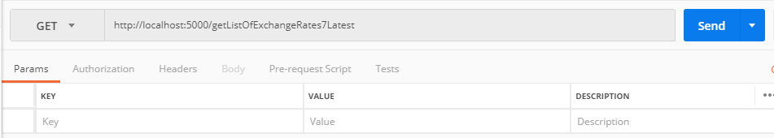

## **Contoh Response**

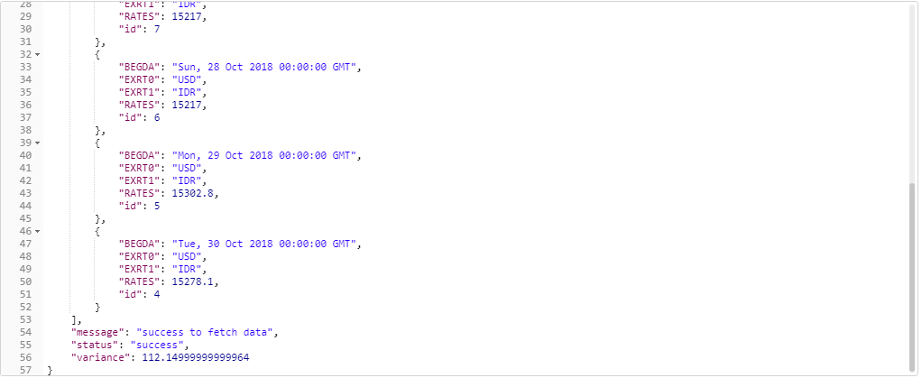

# **Insert Currency Exchange**

API untuk mendaftarkan nilai mata uang kedalam exchange rate

## **Request**

|  |  |  |
| --- | --- | --- |
| URL | http://localhost:5000/postCurrencyExchange | |
| Method | POST | |
| Header Parameter | Content-Type | Application/json |
| Body Parameter | EXRT0 | From Currency |
|  | EXRT1 | To Currency |

## **Response**

* Success
  + Success to insert data
* Failed
  + Failed to insert data

## **Contoh Request**

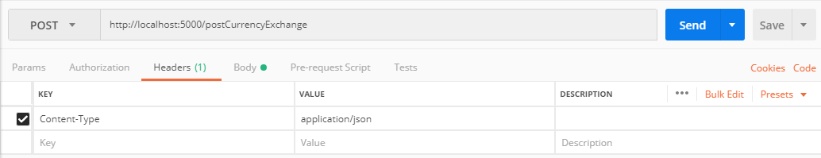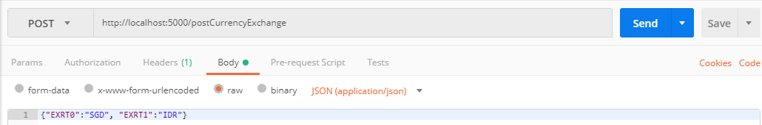

## **Contoh Response**

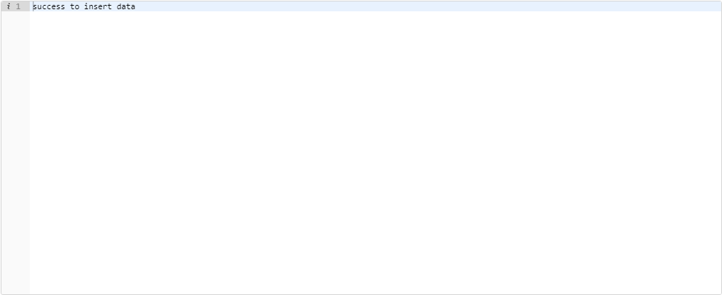

# **Insert Daily Exchange Rates**

API untuk memasukkan nilai exchange rates dari satu mata uang ke mata uang lainnya yang terdaftar.

## **Request**

|  |  |  |
| --- | --- | --- |
| URL | <http://localhost:5000/postDailyExchangeRate> | |
| Method | POST | |
| Header Parameter | Content-Type | Application/json |
| Body Parameter | BEGDA | Tanggal saat input exchange rates |
|  | EXRT0 | From Currency |
|  | EXRT1 | To Currency |
|  | RATES | Nilai exchange rate |

## **Response**

* Success
  + Success to insert data
* Failed
  + Failed to insert data

## **Contoh Request**

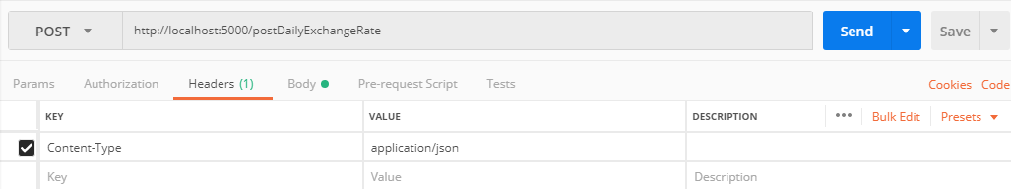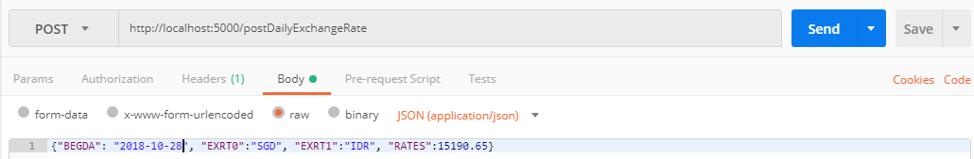

## **Contoh Response**



# **Delete Currency Exchange**

API untuk menghapus mata uang dari list exchange rate

## **Request**

|  |  |
| --- | --- |
| URL | http://localhost:5000/deleteCurrencyExchange/{EXRT0}/{EXRT1} |
| Method | DELETE |
| Header Parameter | - |

## **Response**

* Success
  + Success to delete data
* Failed
  + Failed to delete data

## **Contoh Request**

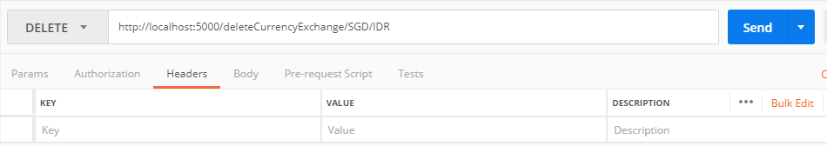

## **Contoh Response**

